English title (for all papers)

Name Surname¹, Name Surname² & Name Surname^{1,2}

¹Institution 1 (e.g. Palacký University Olomouc)

²Institution 2 (e.g. Slovak Academy of Science)

Manuscript instructions for authors
Manuscript should be 5–10 pages long (incl. title, abstract, key words, tables, figures, references etc.) and formatted according to this template. Authors should keep the predefined MS Word styles and follow APA style (see APA Publication Manual, 7th ed.).
https://www.scribbr.com/apa-style/apa-seventh-edition-changes/
https://www.scribbr.com/apa-citation-generator/
https://forums.zotero.org/discussion/80984/changes-to-apa-style-in-7th-edition
https://www.scribbr.com/apa-style/tables-and-figures/
https://www.scribbr.com/apa-style/apa-reference-page/
Authors should use headings to organize the text. The level 1 headings follow the IMRaD (Introduction, Method, Results, Discussion) structure.

Heading Level 1

Heading Level 2

Heading level 3. Followed by text…

Heading level 4. Followed by text…
Tables and figures should be placed in text and formatted according to the APA Publication Manual (7th ed., chapter 7) with headings in format: Table X. Description of the table or Figure X. Description of the figure. Examples are listed below.

Table 1

Descriptive statistics for Police officers and Firefighters
 | Emotional Intelligence |  |  | Job Performance
 | n | M | SD | n | M | SD
Police Officers | 120 | 8.26 | .95 | 120 | 6.63 | .86
Firefighters | 113 | 7.13 | 1.02 | 113 | 7.12 | .79

Note. For assessing emotional intelligence was used MSCEIT.

Figure 1

Confirmatory Factor Analysis Model
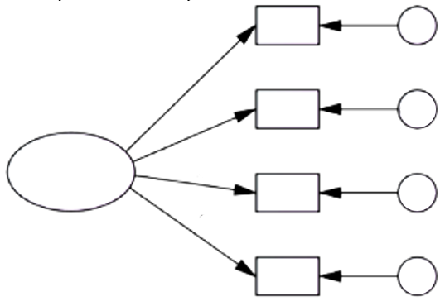
All included tables and figures should be mentioned in the text of the manuscript. Example:
LMX theory is one of the most influential and most famous leadership theories, mainly due to the ability to predict the various variables that are desirable for organizations (Day & Miscenko, 2015; Gooty & Yammarino 2016). A study by Flickinger et al. (2016) showed a positive relationship between the quality of a leader's relationship with his/her followers and job satisfaction with regular employees. According to Northouse (2010) this theory works in two ways
(see Figure 1). The development of LMX according to Graen and Uhl-Bien (1995) is divided into four stages (see Table 1).
All cited sources should be mentioned in Literature section. All references in References section should be cited in the manuscript.

Note. One factor model.

Our recommendation is to focus on journals from Q1 and Q2 quartiles (such as Journal of Management, Quarterly Journal of Economics, Journal of Human Resources, Journal of International Business Studies, Journal of Finance, Journal of Management Studies, Journal of Financial Economics, Review of Economic Studies...) from last two years.

References
Day, D. V., & Miscenko, D. (2015). Leader-member exchange (LMX): Construct evolution, contributors, and future prospects for advancing leadership theory. In T. N. Bauer, & B. Erdogan (Eds.), The Oxford handbook of leader-member exchange (pp. 9–28). Oxford University Press.
Flickinger, M., Allscher, M., & Fiedler, M. (2016). The mediating role of leader-member exchange: A study of job satisfaction and turnover intentions in temporary work. Human Resource Management Journal, 20(1), 46–62. https://doi.org/10.1111/1748-8583.12091
Gooty, J., & Yammarino, F. J. (2016). The leader-member exchange relationship: A multisource, cross-level investigation. Journal of Management, 42(4), 915–935. https://doi.org/10.1177/0149206313503009
Northouse, P. G. (2010). Leadership: Theory and practise (5th ed.). SAGE Publications, Inc.

Corresponding author

Dr. Peter Value

University of Economics in Bratislava, Faculty of Business Management, Department of Business Economy

Dolnozemska cesta 1, 852 35 Bratislava, Slovak Republic
smallpvalue@euba.sk

